**DAILY ONLINE ACTIVITIES SUMMARY**

|  |  |  |  |  |  |  |  |  |
| --- | --- | --- | --- | --- | --- | --- | --- | --- |
| **Date:** | **20/5/2020** | | | | | **Name:** | **Apoorva U** | |
| **Sem & Sec** | **8th Sem** | | | | | **USN:** | **4AL16CS017** | |
| **Online Test Summary** | | | | | | | | |
| **Subject** | | **Internet of Things: Module 1 & Module 2** | | | | | | |
| **Max. Marks** | | **30** | | **Score** | | | **24** | |
| **Certification Course Summary** | | | | | | | | |
| **Course** | **DataCamp :Introduction to Python** | | | | | | | |
| **Certificate Provider** | | | **Datacamp** | | **Duration** | | | **4 hrs** |
| **Coding Challenges** | | | | | | | | |
| **Problem Statement:**  1:Write c program to reverse a linked list in group of given size.  2:Python program to reverse a given number. | | | | | | | | |
| **Status:COMPLETED** | | | | | | | | |
| **Uploaded the report in Github** | | | | | **yes** | | | |
| **If yes Repository name** | | | | |  | | | |
| **Uploaded the report in slack** | | | | | **yes** | | | |

Online Test Details: (Attach the snapshot and briefly write the report for the same)

Certification Course Details: (Attach the snapshot and briefly write the report for the same)

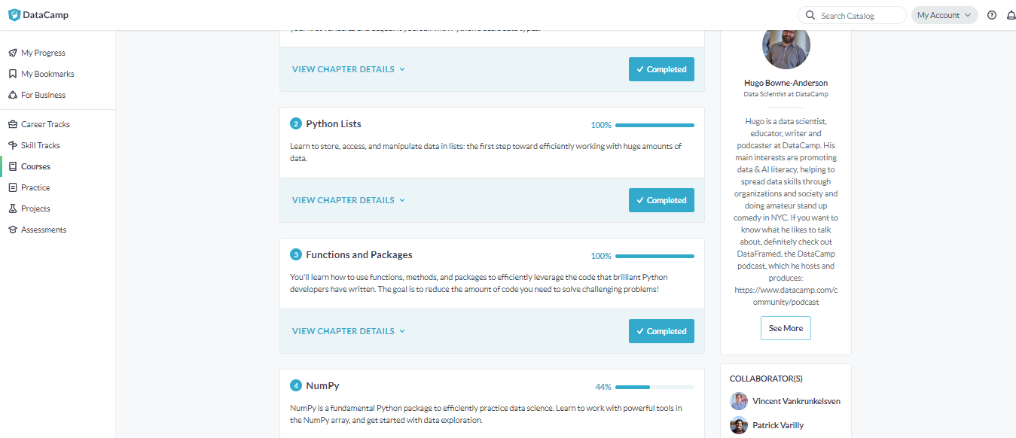

Coding Challenges Details: (Attach the snapshot and briefly write the report for the same)

Program1:

struct Node

{

int data;

struct Node* next;

};

pointer to the new head node. */

struct Node *reverse (struct Node *head, int k)

{

struct Node* current = head;

struct Node* next = NULL;

struct Node* prev = NULL;

int count = 0;

while (current != NULL && count < k)

{

next = current->next;

current->next = prev;

prev = current;

current = next;

count++;

}

if (next != NULL)

head->next = reverse(next, k);

return prev;

}

void push(struct Node** head_ref, int new_data)

{

struct Node* new_node =

(struct Node*) malloc(sizeof(struct Node));

new_node->data = new_data;

new_node->next = (*head_ref);

(*head_ref) = new_node;

}

void printList(struct Node *node)

{

while (node != NULL)

{

printf("%d ", node->data);

node = node->next;

}

}

int main(void)

{

struct Node* head = NULL;

push(&head, 8);

push(&head, 7);

push(&head, 6);

push(&head, 5);

push(&head, 4);

push(&head, 3);

push(&head, 2);

push(&head, 1);

printf("\nGiven linked list \n");

printList(head);

head = reverse(head, 2);

printf("\nReversed Linked list \n");

printList(head);

return(0);

}

**Program 2:**

n=int(input("Enter number: "))

rev=0

while(n>0):

dig=n%10

rev=rev*10+dig

n=n//10

print("Reverse of the number:",rev)

Program 3:

x=10

y=12

x=x^y

y=x^y

x=x^y

print(After Swapping:x=”,x”,y”=”,y)